Healthcare in prison

Unit 1
People in healthcare



English to help you understand how to get help when you are ill in prison

Contents

How to use this workook | Page 3
Workbook 1: People in healthcare Task 1 | Page 5
Workbook 1: People in healthcare Task 2 | Page 7
Workbook 1: People in healthcare Task 3 | Page 19
Workbook 1: People in healthcare Task 4 | Page 13
Workbook 1: People in healthcare Task 5 | Page 15
End of Workbook 1 progress check | Page 17
Workbook 1 Answer key | Page 29

Introduction

This workbook has three sections. You can use this workbook to practise English in your pad. The answers are at the back of the book. The book is yours to keep.
This workbook contains activities on:

- reading
- speaking clearly
- vocabulary
- grammar
- writing

You need a pen or pencil.

Read the instructions for each task carefully.

Do the activities then check your answer using the ANSWERS pages at the back of the workbook.

There is sometimes some information to read:

Information
If you see a box like this, read the information carefully. It will help you with the next task.

Sometimes you have to do some work outside your cell:

If you see something in a box like this, it means you have to do something outside your cell. For example, maybe you will have to;
- ask someone a question
- check something with your landing officer
- read something
- collect something

Workbook 1: People in healthcare

Learning goals

By the end of this unit you will be able to:

- read and understand a leaflet about healthcare
- know the names for different jobs in healthcare.
- understand what different people do in healthcare.
- understand words and phrases that people in healthcare say.
- say the words for different healthcare jobs clearly.

a | b | c
 | 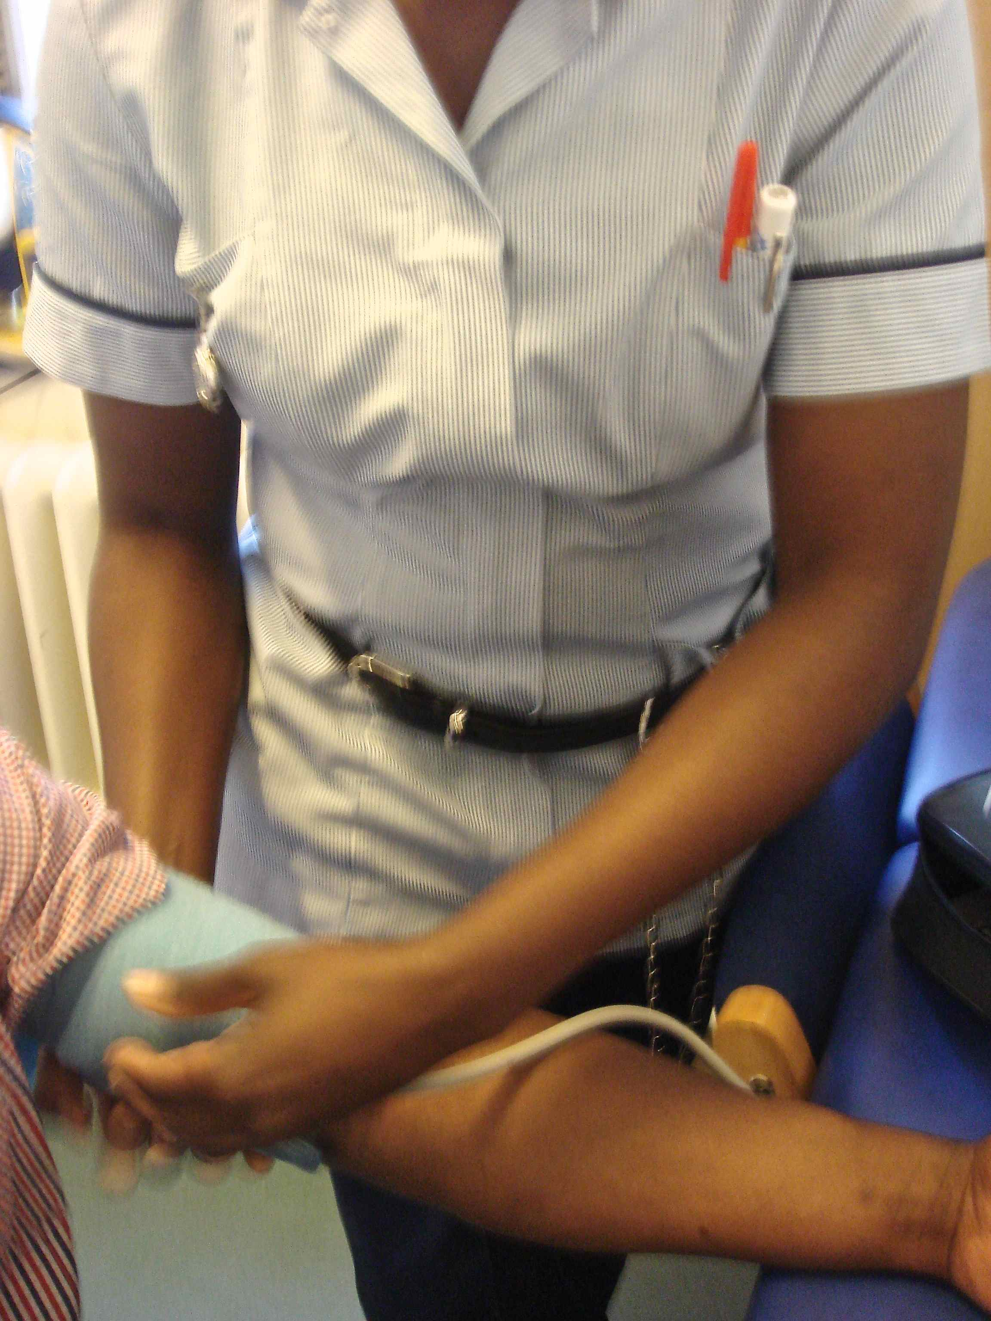 | 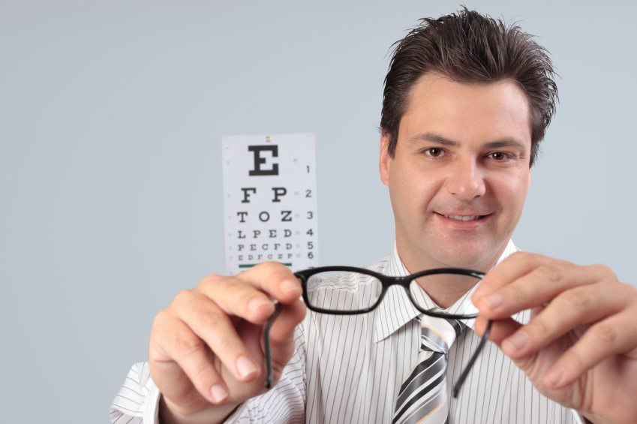
d | e | f
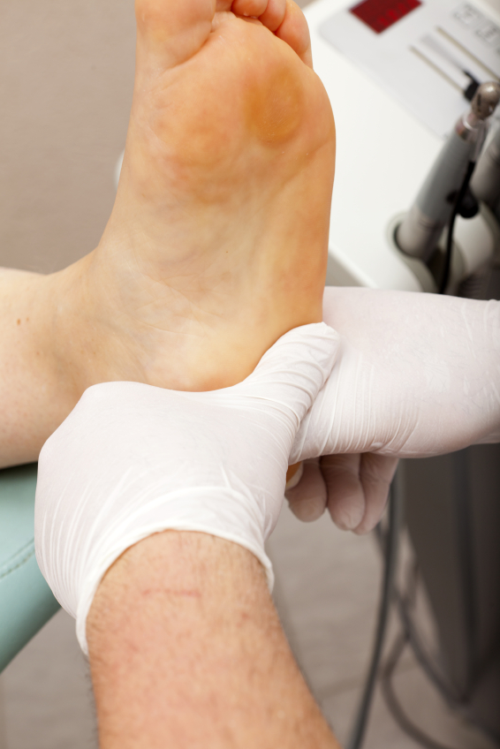 | 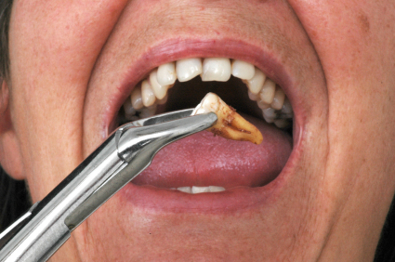 | 

Task 1

- Before you read:

Who works in healthcare? Tick three people.

doctor nurse librarian physiotherapist teacher

2. Read the leaflet 'Welcome to the Healthcare service in prison!'
Welcome to Healthcare in prison!
Going to the doctor or seeing a nurse in prison is just like it is on the outside: there are the same services.
On the wing
- Healthcare assistants: we are prisoners. Our job is to help other prisoners. We can help you fill in applications (apps), find out about appointments or give you support with complaints* if you are not happy about something.
- Pharmacists: we give you your medicines (meds). You can buy things from us too.
Healthcare centre
- Doctor : you see me first, for any illness
- Nurse: I can check your blood pressure or give you injections*
- Optician: I look after your eyes
- Dentist: I look after your teeth
- Physiotherapist: I help you to get better after accidents like a broken leg
- Chiropodist: I take care of problems with your feet
- Mental health in-reach team: we help you with depression*, stress* and when you are feeling sad or lonely.
- Healthcare assistants (full-time)
If you want to see someone from healthcare, speak to a healthcare assistant, an officer or get an application form from the prisoner information desk on the wing.

Glossary – meanings of some difficult words
*depression = when you feel sad for a long time
*stress = when you feel worried and it makes you angry or tired
*injection = use a needle to give medicine into your blood.
*complain = tell somebody you are not happy and ask them to change something. For example, you can complain to the shop if you buy something that is broken

- Look at the pictures in the introduction on page 4. What healthcare jobs can you see in the pictures?

- physiotherapist

- Read the sentences about the healthcare. Are they true or false? Write T for true and F for false.

- The healthcare assistants are prisoners. T
- The chiropodist looks after your knees.
- The pharmacists are on the wing.
- The optician works in the healthcare centre.
- There isn't a dentist.
- Only the doctor gives injections.
- The mental health team can help you if you feel worried.
- Answer the questions about the people in the healthcare centre:
- Who do you see first, if you are ill? the doctor
- What part of your body does the chiropodist look after?__________
- Who do you see for your teeth?_______________
- Who can help if you feel sad or lonely?____________________
- What body part does the optician look after?_________________

Task 2
- Write the sentence under the correct picture in the table.
- I'm very stressed.
- Can I check your blood pressure?
- I've got depression.
- I'm not very happy. I have a complaint.
- Are you ready for your injection?

-  | - 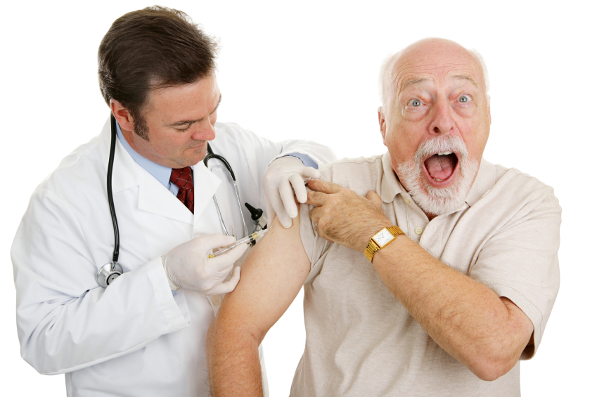
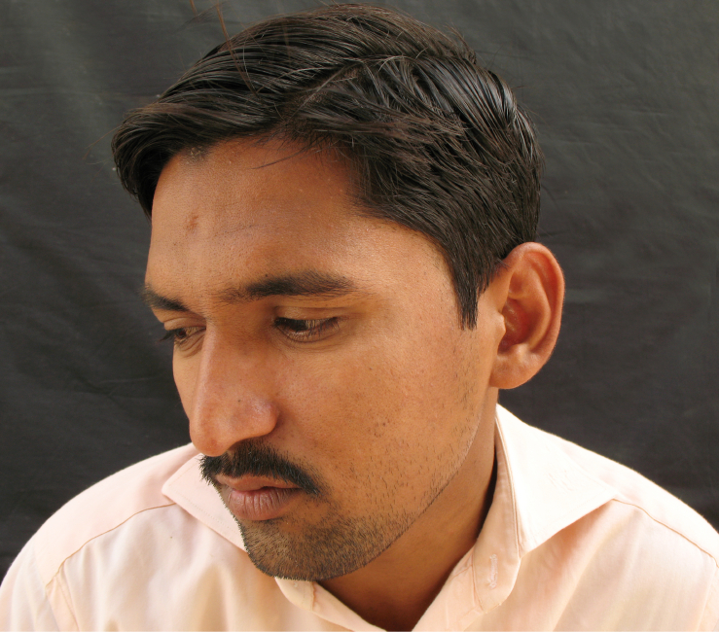 | 
 | - I’m very stressed.
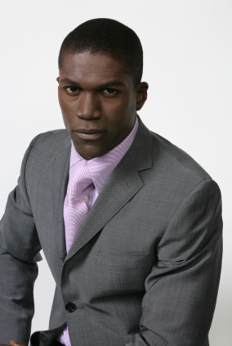 |   Check your answers at the back of the book.
2. Read the prisoners' problems. Who should they see in Healthcare? Write the name of the healthcare worker in the space.

- I've got a bad pain in my foot. It's hard to get shoes that fit – they hurt my big toe. When I'm on my feet, standing, all day, it really hurts. chiropodist
- I don't know how to fill in my app. I don't understand some of the words and I don't know what to write in the boxes. I can't spell in English. _______________
- My tooth hurts…I think I need a new filling. When I eat anything hot or cold, it's really painful. ______________
- I hurt my shoulder in the gym. I can't move it. If I try and lift something with my right arm, it's impossible. It’s difficult to turn my head as well. I've tried paracetamol but it doesn't help. ______________
- I feel very upset and stressed. I'm really tired all the time but I can't sleep. I'm worried about my girlfriend. She's ill and she can't look after our son by herself. ______________
- I need to get my diabetes tablets. I've seen the doctor but I don't know where to get my meds from. _______________________
- I have to get my blood pressure checked. I need to do it every six months because I'm on tablets for it. __________________
- I've got a problem with going to the toilet. I go every five minutes and it hurts a lot. _______________
- It's been a problem for about three months, but I don't want to see a doctor. I'm worried – what if it's serious? __________________________

Tip! Look at the Welcome to Healthcare in prison! leaflet.

Check your answers at the back of the book.

3. Vocabulary: useful phrases

Match the verbs on the left with the phrases on the right. All the phrases are in the sentences in Task 2.2.

turn | on my feet all day | turn my head
get | on tablets
see | my blood pressure checked
look | a doctor
I am | after our son
I am | my head

4. More practice

Fold the page, so you can't see the phrases at the top of this page. Can you remember them? Write one letter in each space.

- turn my head
- g_ _ my b_ _ _ _ _ pressure c_ _ _ _ _ _
- I'm o_ t _ _ _ _ _ _ s
- l_ _ _ a_ _ _ _ our son
- I'm o_ my f_ _ _ _ a_ _ d_ _

Now look at the top of the page. How did you do?
Task 3:

- Read the three conversations with people in healthcare.
Which picture matches each conversation? Write a, b or c.
Conversation 1 is picture b
Conversation 2 is picture _____
Conversation 3 is picture _____


a b c

- Now complete the gaps with the correct words below.

blood complain ready dentist's relax hurt

Conversation 1
Doctor: Hello Mr Ahmed. Are you 1 ready for your injection?
Mr Ahmed: Yes, nurse. But I'm worried. I don't like injections.
Doctor: Don't worry. It won't 2._______. It's very quick!

Conversation 2
Nurse: Mr Gorek, hello! Let me start with your 3.____________pressure.
Mr Gorek: Shall I take off my t-shirt?
Nurse: No, it's ok. Now, just 4.____________ for a moment. Does that feel ok?
Mr Gorek: Yes.
Nurse: Ah, good news. Your blood pressure's normal.

Conversation 3
Healthcare assistant: Hi there Addy, how can I help you mate?
Addy: Hi, I want to .5__________ about something.
Healthcare assistant: What is it?
Addy: It's my 6.____________ appointment. I asked for one six weeks ago but I'm still waiting.
Healthcare assistant: OK. I'll find out for you. What's your prison number?

3. Read the questions and sentences. Who says them? Underline the correct healthcare worker.
- nurse / optician/ dentist
- mental health worker / doctor / dentist
- healthcare assistant / dentist / optician
- mental health worker/ physiotherapist / doctor
- chiropodist/dentist / mental health worker
- healthcare assistant / pharmacist / physiotherapist
- optician / physiotherapist / dentist
- optician / pharmacist / dentist
f. Does your back still hurt?
e. Can I look at your feet, please?
a. How often do you brush your teeth?
d. When did you start feeling sad?
b. I need to listen to your heart, please.
c. Do you need any help to fill in your application?
g. You need new glasses, Mr Shand.
h. Here's your tablet. Take it now please.

4. Grammar: re-order the words and punctuation to make questions and sentences.
- often/ your /you /How/ brush/ teeth/ do/?
How often do you brush your teeth?
- I /to/ to /need/ your/,/ please/. /heart /listen _______________________________________________________
- you / ?/ feeling /start /did /sad /When _______________________________________________________
- still /your /Does/ back/ hurt/? _______________________________________________________
- your /I / ?/ at/ feet/ , / Can/ look/ please _______________________________________________________
- fill /any /your /? /Do/ application/ you/ help/ to /need/in _______________________________________________________
- You /glasses /new /. /need _______________________________________________________

Tip! Look at the underlined words in speech bubbles on the page before. Try to remember the word order for questions: do you…can you…did you….

5. Now complete the questions. Write do/ does/ can in the space.

- Can I look at your teeth please?
- _____ you need any help?
- ______ your back still hurt?
- _______ I listen to your heart please?
- How often ____ you brush your teeth?
- Where _____ it hurt?

Task 4

1. Word list – new words about health

Write the word(s) in your language. Add any other words that are new to you in the spaces.

People in healthcare | translation | Medical words | translation
Mental health worker |  | healthcare
Healthcare assistant |  | injection
Chiropodist |  | appointment
Physiotherapist |  | accident
Nurse |  | Blood pressure
Doctor |  | medicine
Optician |  | broken
dentist |  | diabetes
pharmacist |  | tablets
 |  | complain
 |  | depression
 |  | Relax
 |  | nervous

2. Word search
Can you find all the people who work in healthcare?
Draw a circle around the words. Read from top to bottom or left to right.

c | h | i | r | o | p | o | d | i | s | t
t | h | e | r | a | p | i | s | t | x | p
h | e | a | l | t | h | c | a | r | e | h
p | h | a | r | m | a | c | i | s | t | y
a | s | s | i | s | t | a | n | t | i | s
b | c | h | t | i | m | l | o | o | e | i
d | o | c | t | o | r | n | p | r | s | o
e | m | e | n | t | l | u | t | d | c | t
n | f | e | e | l | o | r | i | o | a | h
t | k | d | o | y | o | s | c | c | n | e
i | w | a | n | t | t | e | i | m | n | r
s | o | d | o | a | n | o | a | c | y | a
t | t | h | i | n | g | s | n | m | y | p
t | e | l | e | s | i | d | c | d | a | i
h | o | n | t | k | n | o | a | d | i | s
i | w | h | a | t | t | o | r | s | c | t

- nurse
- chiropodist
- doctor
- optician
- healthcare assistant
- dentist
- pharmacist
- physiotherapist

Task 5
Speaking clearly

Sound patterns
English spelling is crazy! Many English words and spellings come from different languages. A lot of our medical words are Greek and Latin and are very long and hard to say.

- Can you say these healthcare words correctly?
- chiropodist ch sounds like 'sh' shi ¦ro¦ po¦ dist
- optician ci sounds like 'sh' op¦ ti ¦shun
- injection ti sounds like 'sh' in ¦jek ¦shun
- blood pressure ssu sounds like 'sh' blud ¦presh ¦uh
- physiotherapist ph sounds like 'f' fiz¦ ee ¦o ¦ther¦ a¦ pist
- pharmacist ph sounds like 'f' far ¦muh¦ sist
ci sounds like 's'

Ask someone to help with these activities.
Show them the words.
Say 'Excuse me. How do you say this properly, please?'

Keep practising and the sounds will get easier to say.

2. Syllable stress
Words are made up of parts, called syllables. In English, there are stressed and unstressed syllables. Stressed syllables sound louder and stronger. Unstressed syllables are quiet, quick and sometimes you can't hear them at all.
relax!
different
Examples:

relax re ¦ lax
dentist
different diff ¦e¦ rent diff ¦ rent

dentist den ¦ tist
Now practise saying these words, with the right syllable stress.
It will help you to understand other people, and it will help other people to understand you!

First syllable stress | Second syllable stress
healthcare  mental  prisoner  accident  lonely  medicine  broken | assistant  chiropodist  optician  injection  appointment  complain  depression

3. Syllable stress puzzle. Read the words. Find your way from the start to the finish. All the words should have the same stress patterns- all first syllable, or all second syllable. There is only one possible way.

Start here
healthcare | mental | complain | doctor | dentist | application
people | medicine | injection | lonely | number | waiting
practise | broken | appointment | optician | assistant | treatment
medicine | understand | accident | physiotherapist | impossible | upset
diabetes | pressure | after | glasses | injury | complain
ago | worker | minutes | feeling | tablet | depression
normal | after | serious | worried | chiropodist | support
quickly | slowly | okay | happy | excuse | nervous

End of unit progress check

How much can you remember?

1. What are these jobs? Write the words next to the pictures:

  a. ___________________ |   b. ___________________ |   c. Mental health worker
  d. ___________________ |   e. _____________________ |   f. __________________
score ____
6

2. Who is talking to the patient? Write the job in the space.

1. __________: How are you feeling today, Mr Khan?
Patient: I feel okay, but I'm nervous about my injection. I don't like needles.
___________: Don't worry. It won't hurt.

2. __________: Hello Mr Miller. Can I see your ID? Here's your tablet. Do you need some water with that?
Patient: Yes please.
score ____
2
____________: Here you are. Take it now please.

3. Who should he see? Read the problems and write the name of the healthcare worker in the space.
- My foot hurts. ____________
- My back hurts. ____________
- My tooth hurts. ____________
- I can't see very clearly. ____________
- I feel sad and worried all the the time. ____________
- I need my medicine. ____________
- I want to get my blood pressure checked. ____________
score ____
7

Tip! Use your word list in task 4 to help you with spelling.

Now check your answers in the back of the workbook.

End of unit check

Now you have finished this unit, how do you feel? Tick () the box that is true for you.

 | Yes | A little | No
I can read and understand a leaflet about people in healthcare.
I know the names for different jobs in healthcare.
I can understand what different people do in healthcare.
I can understand words and phrases that people in healthcare say.
I can say the words for different healthcare jobs clearly.

Answer key
Task 1.1
doctor nurse physiotherapist

A teacher works in education – school or college
A librarian works in the library and looks after books

Task 1.3
a pharmacist
b physiotherapist
c doctor
d optician
e nurse
f chiropodist

Task 1.4
- T
- F
- T
- T
- F
- F
- T

Task 1. 5
- the doctor
- your feet
- the dentist
- mental health
- your eyes

Task 2.1
1b
2e
3c
4a
5d

Task 2.2
- chiropodist
- healthcare assistant
- dentist
- physiotherapist
- mental health team
- pharmacy
- nurse
- doctor

Task 2.3
turn | my head
get | my blood pressure checked
see | a doctor
look | after our son
I'm | on tablets
I'm | on my feet all day

Task 3.1
1b
2c
3a

Task 3.2
- ready
- hurt
- blood
- relax
- complain
- dentist's

Task 3.3
- dentist
- doctor
- healthcare assistant
- mental health worker
- chiropodist
- physiotherapist
- optician
- pharmacist

Task 3.4
- How often do you brush your teeth?
- I need to listen to your heart, please.
- When did you start feeling sad?
- Does your back still hurt?
- Can I look at your feet, please?
- Do you need any help to fill in your application?
- You need new glasses.

- Can I look at your teeth please?
- Do you need any help?
- Does your back still hurt?
- Can I listen to your heart please?
- How often do you brush your teeth?
- Where does it hurt?

Task 5.3. Syllable stress puzzle.
healthcare | mental | complain | doctor | dentist | application
people | medicine | injection | lonely | number | waiting
practise | broken | appointment | optician | assistant | treatment
medicine | understand | accident | physiotherapist | impossible | upset
diabetes | pressure | after | glasses | injury | complain
ago | worker | minutes | feeling | tablet | depression
normal | after | serious | worried | chiropodist | support
quickly | slowly | okay | happy | excuse | nervous

Task 4 Wordsearch solution- people in healthcare
c | h | i | r | o | p | o | d | i | s | t
t | h | e | r | a | p | i | s | t | x | p
h | e | a | l | t | h | c | a | r | e | h
p | h | a | r | m | a | c | i | s | t | y
a | s | s | i | s | t | a | n | t | i | s
b | c | h | t | i | m | l | o | o | e | i
d | o | c | t | o | r | n | p | r | s | o
e | m | e | n | t | l | u | t | d | c | t
n | f | e | e | l | o | r | i | o | a | h
t | k | d | o | y | o | s | c | c | n | e
i | w | a | n | t | t | e | i | m | n | r
s | o | d | o | a | n | o | a | c | y | a
t | t | h | i | n | g | s | n | m | y | p
t | e | l | e | s | i | d | c | d | a | i
h | o | n | t | k | n | o | a | d | i | s
i | w | h | a | t | t | o | r | s | c | t

End of unit 1 progress check:
1.
a. optician
b. pharmacist
c. mental health worker
d. doctor
e. nurse
f. chiropodist

2.
1. nurse or doctor
2. pharmacist

3.
- chiropodist
- physiotherapist
- dentist
- optician
- mental health worker
- pharmacist
- nurse

